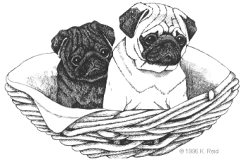Questionnaire For a CandyLand Pug

The reason for this questionnaire is to help us find the right match for you and your CandyLand puppy or adult. Please answer all the questions and return to me. Email is the preferred method.

We want all new owners of a CandyLand pug to be happy as you form your new family, so please bear with us and answer these few questions.

- Do you have or have you ever owned a Pug? If yes, Please give details about the dog. If you currently own a pug, tell me if the dog is altered or still intact.

- Do you have a color preference for a Pug?

- Do you have a sex preference?

- Do you know that Pugs have issues with heat?

- Do you have central air conditioning?

- Do you own or rent your home?

- If you rent do you have approval of your landlord for a dog?

- Do you have a fenced yard?

- Do you have a swimming pool? Jacuzzi? Do your dogs have access to them?

- How many adults are in your family?

- Do you have minor children in your household? How many and their ages?

- If the answer to the above is YES, have the children had other dogs? I so, what breeds?

- Do you presently have other pets? What do you have?

- Are you interested in showing dogs? If yes, please give a history of any showing you have done.

- Are you interested in breeding dogs?

- Are you interested in an older dog? If yes, please give me details as to what you would like.

- When you travel, what arrangements will you make for the care of your dog?

- If adults work outside the home what arrangements will you make for the care of your dog?

- Who will be responsible for the care and welfare of this dog?

- Do you belong to a kennel club and if so which ones?

- Please give 3 personal references.

- Please give any veterinary references.

- Please tell me what attracted you to the pug breed.

- Do you smoke?

Please provide the following information:
Name:
Address:
Phone:
Email:

Should you purchase a CandyLand Pug from us we believe you are then part of our extended family and we will want to receive updates on your puppy as they grow. Would you have a problem with keeping in touch with us?

Please be aware that should you for ANY reason no longer be able to care for this dog, we MUST be advised prior to your relinquishing the dog to ANYONE. We reserve the right to approve any new home.

Thank you so much for your information.We look forward to hearing from you.

J. Candy Schlieper
CandyLand Pugs

